**EXERCISE 1**: Good vs Bad design

**Aim:**

To design a user interface app login page using figma.

**Procedure:**

1. **Sign Up & Create a Project:**

* Sign up at figma.com and create a new project by clicking “New File.”

1. **Create the Frame (Artboard):**

* Use the “Frame” tool (F) to select a mobile preset (e.g., iPhone 13) as your canvas.

1. **Design the Login Screen:**

* **Background Color:** Select the frame and choose a background color (e.g., light blue).
* **Logo:** Draw a placeholder with the “Rectangle” tool (R) and use the “Text” tool (T) to add the app name.
* **Input Fields:** Use rectangles to create username and password fields with placeholder text, and apply rounded corners.
* **Login Button:** Create a button using a rectangle, set the color to blue, and add text inside. Group them together (Ctrl/Cmd + G).
* **Align Elements:** Use alignment tools and the “Auto Layout” feature (Shift + A) for spacing.

1. **Prototyping the Interaction:**

* Use the “Prototype” tab, link the “Login” button to the next screen, and set the interaction to “On Click” with an animation (e.g., Smart Animate).

1. **Preview the Design:**

* Click the “Play” button to preview the prototype and test the interaction.

1. **Share Your Design:**

* Click “Share” to invite team members or generate a link, adjusting permissions for viewing/editing.

1. **Export Assets:**

* Select elements to export (e.g., logo or button), click “Export,” and choose a format (PNG, JPG, SVG).

**BAD DESIGN:**

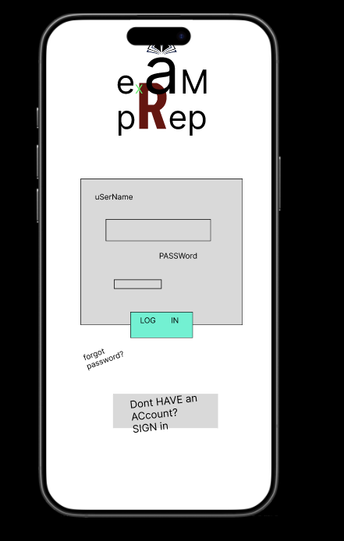

**GOOD DESIGN:**

FRAME 1: FRAME 2:

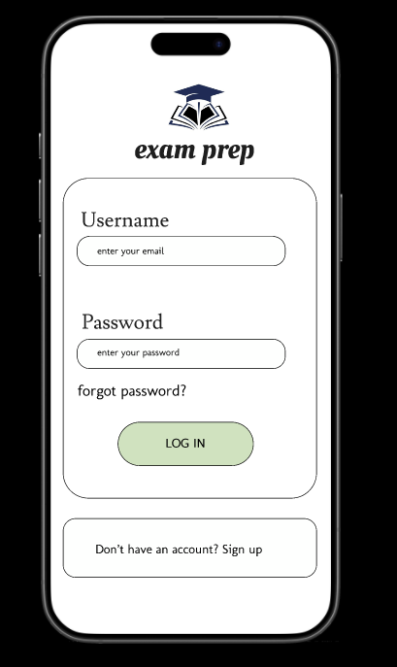 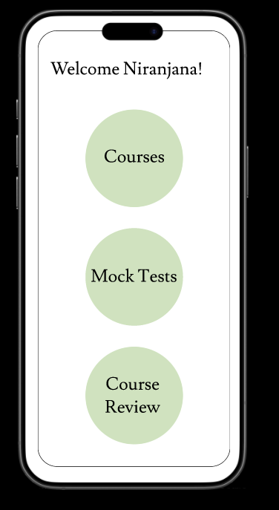

**LINK:**

<https://www.figma.com/proto/AaO37qDEzuwZdSzdLZNfTY/Untitled?node-id=2-13&starting-point-node-id=2%3A13&t=5FkKyC7HRhZf9FVL-1>

**Result:**

A user interface login page for an app is created in figma along with a bad and good design.